For Submission to: Pest Management Science or Journal of Pest Science

A standard set of microsatellite-SSR markers and reference alleles for diagnostic molecular identification of genotypes of Grape Phylloxera (Daktulosphaira vitifoliae Fitch) in Australia

Mark J. Blacket ¹, Isabel Valenzuela¹ and Ary A. Hoffmann ²

¹ Agriculture Victoria, , AgriBio, LaTrobe University, Bundoora, 3083, Australia
² Department of Genetics / Zoology, Bio21 Institute, University of Melbourne, Parkville, 3052, Australia

Corresponding Author:
Mark J. Blacket
E-mail: mark.blacket@agriculture.vic.gov.au
Phone: +61 (03)-9032-7333

Running Head: Standard SSR Markers for Grape Phylloxera

Key Words: Grape Phylloxera; Daktulosphaira vitifoliae; Microsatellite – SSR markers; Molecular diagnostics; Viticulture; Insect pest Australia; Allele size calibration.
Abstract

Grape Phylloxera, Daktulosphaira vitifoliae, is the most destructive insect pest of grape vines, they live on roots and leaves reducing grapevine productivity and can even cause vine death. Originating from North America they have spread to most major viticultural regions of the world over the last two centuries. The main mode of reproduction outside its original range appears to be parthenogenetic (clonal), and identification of different phylloxera genotypes is a major aspect of control, as these differ greatly in their virulence and susceptibility to control through resistant rootstocks. Microsatellite or Single Sequence Repeats (SSR) markers have been developed multiple times for phylloxera over the past decade, and these are now the most common molecular method used for the diagnostic genotype identification. In the current study we suggest a standard set of eight variable microsatellites (Dvit1- Dvit6, DVSSR3 and DVSSR4) that have proven reliable and have been commonly applied. These are proposed as the standard set of SSR’s that should be included in future Australian studies to link with previous work. We present laboratory methods for amplifying these markers in three multiplex (and one single) PCR reactions, which can be pooled and screened through fluorescent genotyping. Interestingly, switching phylloxera genotyping methods from polyacrylamide gel systems to an ABI capillary platform resulted in significant size shifts of alleles for most loci; these were resolved by applying a calibration factor to the capillary genotypes, to compensate for apparent incremental differences in fragment sizes between genotyping platforms. Additionally, the two most common clonal lineages of phylloxera known from Australia (G1 & G4), are proposed here as reference samples for use in calibrating genotyping systems to ensure universal scoring of allele sizes between laboratories.
Introduction

Grape phylloxera, Daktulosphaira vitifoliae Fitch (Hemiptera: Phylloxeridae), are small yellow sap sucking insects related to aphids that feed on the leaves and roots of grapevines. Originally native to North America, they have spread to all major grapevine growing regions of the world, apart from Chile (Powell, 2008), where they are the major insect pest of commercial grape production (Granett et al., 2001).
On Vitis vinifera L. (European Grape Vine) phylloxera cause damage to leaves (galls) and roots (nodules or tuberosities); feeding results in reduced vine productivity and on roots can result in vine death (Granett et al., 2001; Herbert et al., 2007). Surveillance, quarantine of infected areas, and the use of resistant rootstocks derived from native American Vitis species are currently the primary forms of control (Granett et al., 2001; Benheim et al., 2012). The main mode of reproduction of phylloxera outside the Americas appears to be parthenogenetic, i.e. asexual / clonal (Corrie et al., 2002; Vorwerk & Forneck, 2006; Umina et al., 2007; Vorwerk & Forneck, 2010; Sun et al., 2011), and identification of different parthenogenetic lineages through molecular testing (genotyping) is a major aspect of control of this pest (Umina et al., 2007), with genotypes differing greatly in their virulence and susceptibility to control through rootstocks (Herbert et al., 2010; Korosi et al., 2011).
Various molecular markers have been employed to examine phylloxera genetic diversity, including RAPD’s (Random Amplification of Polymorphic DNA) (Fong et al., 1995), AFLP’s (Amplified Fragment Length Polymorphisms) (Forneck et al., 2000), and mitochondrial DNA sequences (Downie et al., 2001; Downie, 2002; Corrie & Hoffmann, 2004; Umina et al., 2007). However, over the last decade microsatellite or Single Sequence Repeats (SSR) markers have been developed multiple times for phylloxera (Corrie et al., 2002; Lin et al., 2006; Vorwerk & Forneck, 2006), including recent studies identifying more than 1000 new SSR loci (Lin et al., 2012; Riaz et al., 2014). SSR markers are now the preferred molecular method for genotype identification The most up to date list of commonly used SSR markers is summarized in Tello & Forneck (2019).

Methods for assigning a genotype have changed in recent times from visual inspections of PCR products on an acrylamide gel to an automated assessment of fluorescently labeled fragments (capillary electrophoresis) (ref.). This new technology has many advantages (ref.) which explains its broad adoption throughout the world in population genetic studies and phenotype-genotype studies (ref.). There are however some problems that arise from changing technologies. One being that old data may not be comparable to new data due to allele size changes and different scoring methods (ref.). This can be resolved by creating standard alleles set as controls and adjusting allele sizes to match old data. This adjustment is important for maintaining congruent biological information between studies and is particularly important in applied sciences e.g., tailored genotype pest management strategies. In addition to this, high throughput methods have also been developed recently such as multiplexing. This involves multiple loci being amplified in a single PCR reaction which has the advantage of reducing time as well as minimizing reagents and costs (ref.). Both technologies combined (fluorescent labeled fragments and multiplexing) have the potential to improve the field of diagnostics as turnaround times are significantly reduced.

All phylloxera genotype data from Australian populations has been generated using the visual assessment of PCR products on acrylamide gels (Corrie et al., 2002; 2003; Corrie & Hoffmann 2004; Umina et al., 2007). The genotypes and the allele sizes of Australian populations are well characterized based on this technology, but some adjustments are required now that the technology has changed from visual inspections of PCR products to an automated assessment. Australian biosecurity agencies have been surveying the presence of phylloxera since it was first detected in xxxx (ref.), and in more recent times, requesting that the genotype is known, particularly for new detections (ref.). Genotype characterization allows to monitor the movements of this pest between and within regions and, between and within vineyards (ref.). Thus, ongoing surveys have taken place particularly over the last 10 years approximately, that have generated large datasets (temporal and spatial datasets) that help understand how this pest spreads. These datasets are extremely valuable resources for comparative purposes e.g., new detections can potentially be linked to an area of origin and thus assist growers with their management strategies. Hence, the importance of linking new data with the old. Genotype information also assists growers with rootstock selection, an important aspect of pest management strategies.

Thus, in view of the implementation of new technologies on phylloxera diagnostic work and the importance of this diagnostic test in biosecurity, we developed a protocol to standardize the entire workflow from DNA extraction to scoring alleles. This protocol is part of the Standard Operating Protocol for phylloxera genotyping work carried out at Agribio, the Victorian government agricultural research institute based at Bundoora, Australia. The aims of the current study were to i) examine the allelic variation of previously untested phylloxera SSR markers (Lin et al., 2006) on Australian phylloxera populations, and ii) develop new laboratory methods based on multiplex PCRs using fluorescently labelled universal primers and iii) and alleles screened through automated fluorescent genotyping with appropriate adjustments following a set of reference alleles. The aim of this work is to recommend a subset of SSR markers for use as the ‘standard set’ to link new data with previous Australian phylloxera work. We present laboratory methods for amplifying a set of SSR markers via multiplex PCR with tailed-forward and fluorescently labelled universal primersAlso, two of the most common genotypes of phylloxera known from Australia (G1 & G4), are proposed as reference samples for use in calibrating genotyping systems to ensure universal scoring of allele sizes and data compatibility between laboratories (Morin et al., 2000); as has been previously adopted for grapevine genotyping (This et al., 2004).

Methods and Results

Standard Set of SSR Loci
Australian studies of phylloxera microsatellite variation have included to date markers Dvit1-Dvit6 (from Corrie et al., 2002, 2003; Corrie & Hoffmann 2004 and Umina et al., 2007). These markers show high levels of allelic variation with a relatively high number of alleles (e.g., up to 7 alleles for Dvit5) and wide allele size range (e.g., from 125bp to 300bp), the latter aspect being essential for multiplexing PCR purposes. Additional SSR markers (from Lin et al., 2006) were also examined for allelic variation but were found unsuitable for multiplexing except for DVSSR3 and DVSSR4Some of these loci (e.g. DVSSR1 and DVSSR2) have been reported as variable without the allele size range being specified (e.g. Lin et al., 2006; Sun et al., 2011); while other loci, e.g. DVSSR7 and DVSSR9, represent different alleles from a single (low-variability) locus, amplified using identical primer sequences (Lin et al. 2006). Thus, based on available published information of allelic variation, eight loci; six previously used (Dvit1- Dvit6) and two new ones (DVSSR3and DVSSR4) were selected as the preferred SSR set to use based upon their high variability (; Figure 1) and past use (Tello & Forneck 2019).

Phylloxera samples and DNA Extraction
Seven clonal lineages collected from Victorian vineyards (G1, G4, G7, G19, G20, G30 and G38 as per Umina et al., 2007) have been maintained on grapevine plants at the phylloxera research institute based at Rutherglen, Victoria, Australia (Table 1). A few individuals per colony were stored at -20ºC in ~100% ethanol prior to DNA extraction. Individual specimens were removed from ethanol using a paintbrush and air-dried on a tissue for one minute. DNA was extracted using Chelex® (BioRad); specimens were ground in a 1.5 ml Eppendorf tube in a bead mill homogeniser (Qiagen 85210 TissueLyser), containing two 3mm glass beads, 100µl of 5% Chelex, and 3µl Proteinase K (20mg/ml, Qiagen), at 30,000 Hz for one minute. Samples were incubated at 56ºC for 30 minutes, at 90ºC for 8 minutes, and cooled on ice for greater than one hour (or in a -20ºC freezer overnight). Prior to PCR, samples were spun at 13,000 rpm for two minutes in a microcentrifuge, 2µl of template DNA was used for each PCR reaction. Additional samples from previous work were available to use here (Table 1). These were DNA extractions (not insect samples) that had been characterised in a previous study as being G1 and G4 based on Dvt1-Dvit6 loci (ref.). The xx old DNA extractions were kept at -20ºC in 1.5 ml Eppendorf tube with the lid wrapped in parafilm to avoid desiccation of the DNA extract.

PCR amplification
The laboratory methods employed in the present study are outlined briefly below, and in the Supplementary Material. Loci were amplified using tailed versions of previously published primers (see Supplementary Material) together with fluorescently labelled universal primers in multiplex PCR reactions and a commercial multiplex PCR kit (Qiagen), sensu Blacket et al. (2012), using an Eppendorf thermocycler (epgradient S). Four PCR reactions were performed: (1) Dvit4/Dvit6/DVSSR4 (annealing 45ºC); (2) Dvit1/DVSSR3 (annealing 47ºC); (3) Dvit5 (annealing 49ºC); and (4) Dvit2/Dvit3 (annealing 57ºC). These four amplifications can be performed simultaneously in a single gradient PCR machine if the sample numbers are low. Many of the loci with larger PCR fragment sizes (Dvit2, Dvit6 & DVSSR3) required double the amount of locus specific primer to be used to avoid preferential amplification of smaller sized loci in multiplex reactions (see Supplementary Material). Further details of each PCR master-mix and PCR amplification profiles are outlined in the Supplementary Material. Half of each PCR (5µl) was run on a 3% agarose gel to confirm amplification, 1 µl of each PCR was then diluted 1:20 with dH₂O in preparation for genotyping. PCR 1 and 2 were poolplexed (i.e. mixed post PCR), as were PCR 3 and 4, to reduce the genotyping of all eight loci down to two capillary lanes for each sample.

Genotyping
Capillary separation was performed commercially (through AGRF Melbourne) on an Applied Biosystems ABI 3730 DNA analyzer, and genotyping was conducted in Geneious R11 (Biomatters Ltd.), using the LIZ500_3730 size standard. An example of typical genotyping results obtained in the present study is shown in Figure 1. Pherograms shown are from genotypes G1 and G4 (the reference genotypes based on old DNA extractions) and G1, G4, G7, G19, G20, G30 and G38 (the Rutherglen colonies) (Fig 1). The old DNA extractions served as controls from which to adjust allele sizes. These two common strains from Australia (G1 & G4) were selected as standard reference samples for use in calibrating genotyping systems (Figure 2; Table 3). Replicated ten previously screened samples of each ….

Absolute fragment sizes obtained from Geneiouswere adjusted to remove the length of the forward primer tails (minus 15 to 18 b.p., see Supplementary Material). An additional conversion factor was applied to Dvit loci due to apparent size shifts (requiring the addition of up to 4 b.p., Table 3) caused from changing from an acrylamide to capillary ABI genotyping platform (discussed further below). The laboratory methods outlined here were used on DNA samples that had previously been identified (Australian genotypes: G1, G4, G7, G19, G20, G30 and G38) through genotyping on polyacrylamide gels (Korosi et al. 2011, Umina et al. 2007). Adjusting the absolute allele sizes obtained from Geneiousto compensate for the forward primer universal tails and applying calibration factors (Figure 3, Table 3) resulted in alleles at the expected sizes (Umina et al. 2007).

Further genotyping efficiency could be achieved by poolplexing all PCR reactions together prior to capillary separation, with fluorescent labels specifically chosen (Figs 1; 2) to potentially allow this possibility. However, although none of the loci tested here have alleles that are known to be identical in size, for ease and accuracy of genotyping it appears preferable to genotype individuals as two poolplex reactions (Figure 2), reducing any potential error caused through fluorescent dye “bleed through” for pairs of loci whose allele size range overlaps in size (e.g. Dvit1/Dvit5, Dvit2/DVSSR3).

Discussion

There are currently diverse genotyping methods used for screening SSR loci in different laboratories worldwide, mostly involving polyacrylamide gels, but employing various methods to visualise / genotype alleles (ref.). However, presently the generally preferred method of genotyping microsatellites is capillary fluorescent screening (Guichoux et al., 2011), which has been used but so far not universally adopted for phylloxera genotyping (Table 1). Additionally, most loci are currently amplified individually (i.e. singleplex PCR). In the present study we address these issues by providing new laboratory methods for amplification of phylloxera SSR markers via multiplex PCR (Supplementary Material) and genotyping using fluorescent labels (Figure 2), thus greatly improving the efficiency of genetic screening.

Screening via multiplex PCR is known to increase genotyping efficiency (Guichoux et al., 2011) and has become increasingly feasible through the widespread use of commercial multiplex kits that employ hot start enzymes (e.g. Elnifro et al. 2000). In the present study microsatellite markers were successfully amplified via multiplex PCR reactions using previously developed phylloxera SSR primers (from Corrie et al., 2002; Lin et al., 2006; and Umina et al., 2007) and screened using fluorescently labelled universal primers (sensu Blacket et al., 2012). PCR amplifications were performed here in three multiplex reactions and one single reaction. Ideally, it would be preferable to reduce these even further, however combining loci into fewer reactions proved difficult with multiplex trials showing that combinations of loci involving Dvit5 generally generated strong primer dimers; while other loci, Dvit4 and Dvit5, both required low annealing temperatures to avoid null alleles but could not be combined together in the same PCR reaction due to negative interactions (i.e. non-specific PCR products).

Generally introduced populations of grape phylloxera appear to be highly genetically variable, and even employing a relatively small number of microsatellites (six SSR’s) has previously identified a large number of genotypes from Europe (259 genotypes - Forneck et al., unpublished) and Australia (83 genotypes - Umina et al., 2007). In the present study we have identified eight SSR markers as preferred markers to allow data compatibility with previous work. Potentially increasing the number of markers to eight may differentiate additional strains in introduced populations. For example, Umina et al. (2007) found that increasing the number of loci from four to six SSR markers increased the number of genotypic classes detected by approximately a third, however, they did not detect additional variation within the most viticulturally important areas(Umina et al. 2007).

The markers chosen here have been both widely applied in the identification of phylloxera genotypes (Table 1; 2) and mostly consist of variable di- and tri-nucleotide repeats, possessing allelic variation (see Figure 4) generally consistent with the standard stepwise slippage mutation model (Levinson & Gutman, 1987), producing highly repeatable genotypes (e.g. Umina et al., 2007). Notably the SSR marker Dvit5 (Vorwerk and Forneck, 2006; Umina et al., 2007), consists of a poly-A repeat (Table 1, Figure 4). Single-base repeat markers are known to primarily vary through single-base mutations which can result in difficulty in generating reliably genotypes (e.g. Kelkar et al., 2010). However, this marker has previously proven useful in identification of genotypes (Umina et al., 2007) and was reliably amplified in the present study. The addition here of DVSSR3 and DVSSR4, should prove valuable: 1) improving genotype identification by increasing the number of diagnostic SSR differences, and 2) some alleles from these two loci may be restricted to particular geographic regions (e.g. Lin et al., 2006) potentially making them especially useful for future phylogeographic studies and work on identifying the possible sources of introduced phylloxera populations. All of the markers chosen here are variable possessing multiple alleles at relatively high frequencies (Figure 4), however some of the markers utilised here (e.g. Dvit3) are not particularly highly variable (e.g. Umina et al., 2007; Figure 4), but have proven useful in distinguishing biologically important genotypes of phylloxera (such as G1 & G4 in Australia).

Transferring genotyping from acrylamide gel-based systems to an ABI capillary genotyping platform resulted in apparent allele size shifts in the present study, with the effect generally increasing with larger allele sizes (Figure 3). Such increment size shifts have been previously reported (e.g. Moran et al. 2006, Ellis et al. 2011) and are believed to be due to incremental differences in determining the size of alleles between platforms. (### … ADD actual measurement here from Figure 3 … ###). The single-base repeat locus Dvit5 does not appear to fit the general pattern observed for other Dvit loci examined here, requiring a larger than expected calibration factor for the allele size (Figure 3, Table 3).

The past decade has seen genotypic identification of phylloxera genotypes become an integral part of control of this pest (e.g. Umina et al., 2007). In the current study we have reviewed the previous application of SSR markers and have determined the most common loci that have been employed to date (Table 2). There are several recent developments that will undoubtedly affect future phylloxera genotyping: 1) a large number of new SSR markers have been recently developed (Lin et al., 2012; Riaz et al., 2014), and used in a broad scale population study in North America (Lund et al., 2017; Riaz et al., 2017); 2) the current genome sequencing initiative (Delmonte et al., 2011) will undoubtedly generate a large number of new markers; also 3) introduced populations of phylloxera are beginning to be screened from other regions around the world (e.g. China - Sun et al., 2011). Adoption of the minimal set of SSR markers identified here should help standardise molecular diagnostic identification methods between different research groups, and ensure that future work will be compatible with previously generated data.

Acknowledgments

DAFF (Department of Agriculture, Fisheries and Forestry) provided funding for Mark Blacket to visit the three main diagnostic laboratories currently conducting genotypic work on phylloxera, through a “2011 DAFF Diagnostic Training Scholarship”. We thank everyone who assisted with this scholarship including: Andy Walker, Summaira Riaz, & Karl Lund (University of California, Davis, USA); Astrid Forneck & Roswitha Mammerler (Natural University, BOKU, Tulln, Austria); Vanessa Linley-White & Nancy Endersby (University of Melbourne, Australia), Kevin Powell & Ginger Korosi (DPPR Victoria, Australia). We also thank Kevin Powell and Ginger Korosi for samples of G1 & G4 strains (####… possibly add other four strains also …####) from their earlier glasshouse trial studies.
Catherine Clarke and Bernadette Carmody for rearing and supplying insects.
Who collected the colonies from the field?

References

Benheim D., Rochfort S., Robertson E., Potter I.D., & Powell K.S. (2012) Grape phylloxera (Daktulosphaira vitifoliae) – A review of potential detection and alternative management options. Annals of Applied Biology 161, 91-115.
Blacket M.J. (2012). Draft diagnostic protocols for molecular diagnosis of strains of Grape Phylloxera (Daktulosphaira vitifoliae Fitch) DAFF diagnostic protocol, 34 pp. Plant Health Australia, Canberra.
Blacket M.J., Robin C., Good R.T., Lee S.F., & Miller A.D. (2012) Universal primers for fluorescent labelling of PCR fragments – an efficient and cost-effective approach to genotyping by fluorescence. Molecular Ecology Resources 12, 456–463.
Corrie A.M., Crozier R.H., Van Heeswijk R., & Hoffmann A.A. (2002) Clonal reproduction and population genetic structure of grape phylloxera, Daktulosphaira vitifoliae, in Australia. Heredity 88, 203-211.
Corrie, A. M., Van Heeswijck, R., & Hoffmann, A. A. (2003). Evidence for host-associated clones of grape phylloxera Daktulosphaira vitifoliae (Hemiptera: Phylloxeridae) in Australia. Bulletin of Entomological Research, 93(3), 193-201.
Corrie A.M. & Hoffmann A.A. (2004) Fine-scale genetic structure of grape phylloxera from the roots and leaves of Vitis. Heredity 92, 118-127.
Delmotte F., Forneck A., Powell K., Rispe C., & Tagu D. (2011) Proposal to sequence the genome of the grape Phylloxera (Daktulosphaira vitifoliae Fitch). Phylloxera Genomics Initiative May 2011: 1-10.
Downie D.A., Fisher J.R., & Granett J. (2001) Grapes, galls, and geography: The distribution of nuclear and mitochiondrial DNA variation across host-plant species and regions in a specialist herbivore. Evolution 55, 1345-1362.
Downie D.A. (2002) Locating the sources of an invasive pest, grape phylloxera, using mitochondrial DNA geneology. Molecular Ecology 11, 2013-2026.
Ellis J.S., Gilbey J., Armstrong A. et al. (2011) Microsatellite standardization and evaluation of genotyping error in a large multi-partner research programme for conservation of Atlantic salmon (Salmo salar L.). Genetica 139, 353–367.
Elnifro E. M., Ashshi A. M., Cooper R. J., & Klapper P. E. (2000) Multiplex PCR: Optimization and application in diagnostic virology. Clinical Microbiology Reviews 13, 559-570
Fong G., Walker M. A., & Granett J. (1995) RAPD assessment of California phylloxera diversity. Molecular Ecology 4, 459-464.
Forneck A., Walker M.A., & Blaich, R. (2000) Genetic structure of an introduced pest, grape phylloxera (Daktulosphaira vitifoliae Fitch), in Europe. Genome 43, 669-678.
Guichoux E, Lagache L, Wagner S,Chaumeil P., Léger P., Lepais O., Lepoittevin C., Malausa T., Revardel E., Salin F., & Petit R.J. (2011) Current trends in microsatellite genotyping. Molecular Ecology Resources 11, 591–611.
Granett, J., Walker, M.A., Kocsis, L., & Omer, A.D. (2001) Biology and Management of Grape Phylloxera. Annual Review of Entomology 46, 387 - 412.
Herbert K.S., Hoffmann A.A., Powell K.S., Ophel-Keller K., & Parsons Y.M. (2007) The development of a polymerase chain reaction method for the rapid identification of grape phylloxera in vineyard soil. Proc.3rd Int. Grapevine Symposium. Acta Horticulturae 733, 75 - 87.
Herbert K.S., Umina P.A., Mitrovski P.J., Powell K.S., Viduka K., & Hoffmann A.A. (2010) Clone lineages of grape phylloxera differ in their performance on Vitis vinifera. Bulletin of Entomological Research 100, 671-678.
Kelkar Y.D., Strubczewski N., Hile S.E., Hile S.E., Chiaromonte F., Eckert K.A., & Makova K.D. (2010) What is a microsatellite: a computational and experimental definition based upon repeat mutational behavior at A ⁄ T and GT ⁄ AC repeats. Genome Biology and Evolution 2, 620–635.
Korosi G.A., Carmody B.M. & Powell K.S. (2011) Rootstock screening for phylloxera resistance under controlled conditions using selected phylloxera clonal lineages. Acta Horticulturae 904, 33–39.
Lin H., Islam M.S., & Ramming D.W. (2012) Genome-wide identification and characterisation of simple sequence repeat loci in grape phylloxera, Daktulosphaira vitifoliae. Genetics and Molecular Research 11, 1409-1416.
Lin H., & Walker M.A. (1996) Extraction of DNA from a single egg of grape phylloxera (Daktulosphaira vitifoliae Fitch) for use in RAPD testing. Vitis 35, 87-89.
Lin H., Walker M.A., Hu R., & Granett J. (2006) New Simple Sequence Repeat Loci for the Study of Grape Phylloxera (Daktulosphaira vitifoliae) Genetics and Host Adaptation. American Journal of Enology and Viticulture 57, 33-40.
Lund KT, Riaz S, Walker MA (2017) Population Structure, Diversity and Reproductive Mode of the Grape Phylloxera (Daktulosphaira vitifoliae) across Its Native Range. PLoS ONE 12(1): e0170678. https://doi.org/10.1371/journal.pone.0170678
Moran P., Teel D. J., LaHood E. S., Drake J., Kalinowski S. (2006) Standardising multi-laboratory microsatellite data in Pacific salmon: an historical view of the future. Ecology of Freshwater Fish 15, 597-605.
Morin, P. A., Manaster, C., Mesnick, S. L., & Holland, R. (2009). Normalization and binning of historical and multi‐source microsatellite data: overcoming the problems of allele size shift with allelogram. Molecular Ecology Resources, 9(6), 1451-1455.
Powell K. (2008) "Grape phylloxera: An Overview". In Root feeders An Ecosystem perspective (Eds S.N. Johnson & P.J. Murray) CAB International 2008.
Riaz, S.; Lund, K.; Lin, H.;Walker, M.A. (2014) Development and characterization of a large set of microsatellite
markers for grape phylloxera (Daktulosphaira vitifoliae Fitch). Vitis 53, 95–101.
Riaz, S., Lund, K. T., Granett, J., & Walker, M. A. (2017). Population diversity of grape phylloxera in California and evidence for sexual reproduction. American Journal of Enology and Viticulture, 68 (2), 218-227.
Russell L.M. (1975) Daktulosphaira vitifoliae (Fitch), the correct name of the Grape Phylloxeran (Hemiptera: Homoptera: Phylloxeridae). Journal of the Washington Academy of Sciences 64, 303-308.
Sun Q.-H., Chen Y.-C., Du Y,-P. & Zhai H. (2011) Genetic Structure of Grape Phylloxera in China. Acta Horticulturae 904, 25-32.
Tello, J., & Forneck, A. (2019). Use of DNA Markers for Grape Phylloxera Population and Evolutionary Genetics: From RAPDs to SSRs and Beyond. Insects, 10 (10), 317.
This P., Jung A., Boccacci P., Borrego J., Botta R., Costantini L., Crespan M., Dangl G.S., Eisenheld C., Ferreira-Monteiro F., Grando S., Iba´nez J., Lacombe T., Laucou V., Magalhaes R., Meredith C.P., Milani N., Peterlunger E., Regner F., Zulini L., & Maul E. (2004) Development of a standard set of microsatellite reference alleles for identification of grape cultivars. Theoretical and Applied Genetics 109, 1448–1458.
Umina P., Corrie A., Herbert K., White V., Powell K.S., & Hoffmann A. (2007) The use of DNA markers for pest management-clonal lineages and population biology of grape phylloxera. Acta Horticulturae 733, 183 - 195.
Vorwerk S., & Forneck A. (2006) Reproductive mode of grape phylloxera (Daktulosphaira vitifoliae, Homoptera: Phylloxeridae) in Europe: molecular evidence for predominantly asexual populations and a lack of gene flow between them. Genome 49, 678-687.
Vorwerk S., & Forneck A. (2007) Genetic structure of European Populations of Grape Phylloxera (Daktulosphaira vitifoliae Fitch) as determined by SSR-Analysis. Acta Horticulturae 733, 89-95.
Vorwerk S., & Forneck A. (2010) Lots of clones of Phylloxera (Daktulosphaira vitifoliae) in Europe. Acta Horticulturae 827, 389-392.
Figure Legends

Figure 1. Reported size range of alleles (allelic diversity) and size overlap between phylloxera SSR loci reported in Corrie et al. (2002), Lin et al. (2006), Vorwerk & Forneck (2006), and Umina et al. (2007). Grey shading indicates loci selected as preferred standard markers in the current study, the fluorescent label and universal tail (sensu Blacket et al. 2012) employed in multiplex PCR reactions in the present study is indicated above alleles. Minimum reported allele sizes are shown as squares, maximum sizes as triangles.

Figure 2. Co-amplification of eight Phylloxera microsatellite loci from the Australian strains G1 (2a & b) & G4 (2c & d) by multiplex PCR with tailed-forward and fluorescently labelled universal primers, screened through fluorescent genotyping. Labels below peaks indicate locus names, arrows indicate alleles, filled-arrows indicate alleles that differ between G1 & G4.

Figure 3. Allele size scored on capillary genotyping platform, compared with previously determined sizes (Umina et al. 2007). Allele sizes for six (Dvit) microsatellite loci in phylloxera strains: G1, G4, etc. … ###.

Figure 4. Size and frequency of SSR alleles in Australian strains (Dvit loci, Umina et al. 2007), or European / Californian (DVSSR loci, Lin et al. 1996) strains of Phylloxera. Numbers indicate allele sizes in base pairs.
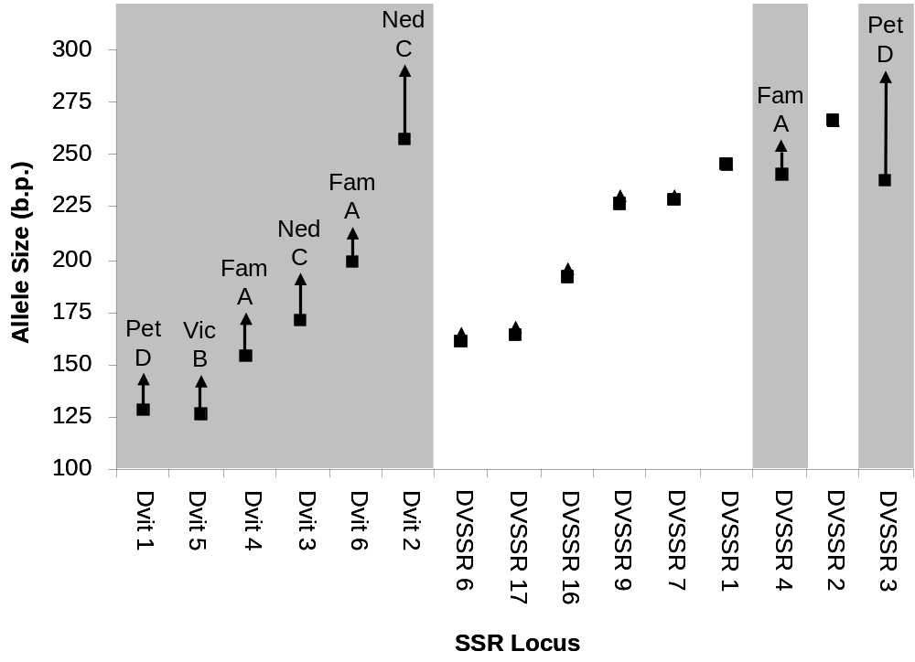
( Figure 1)
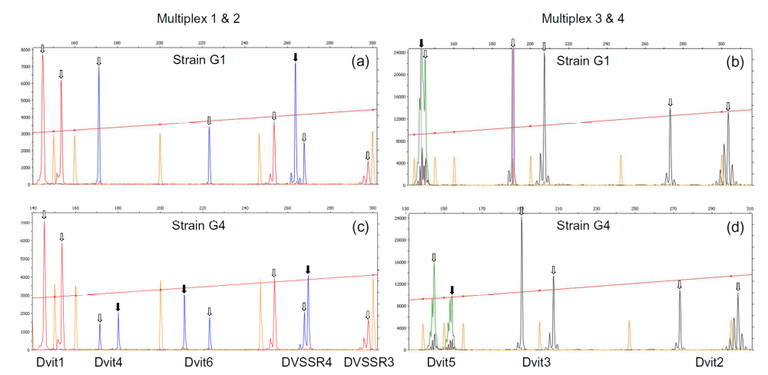

(Fig 2. – Rough Version)

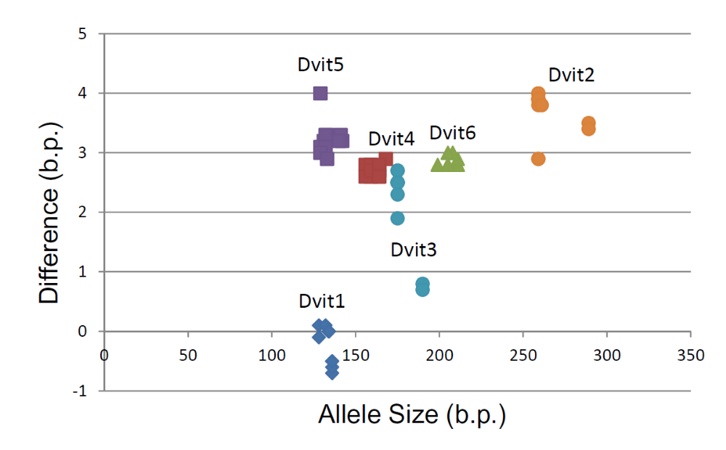
(Figure 3. – Rough Version)
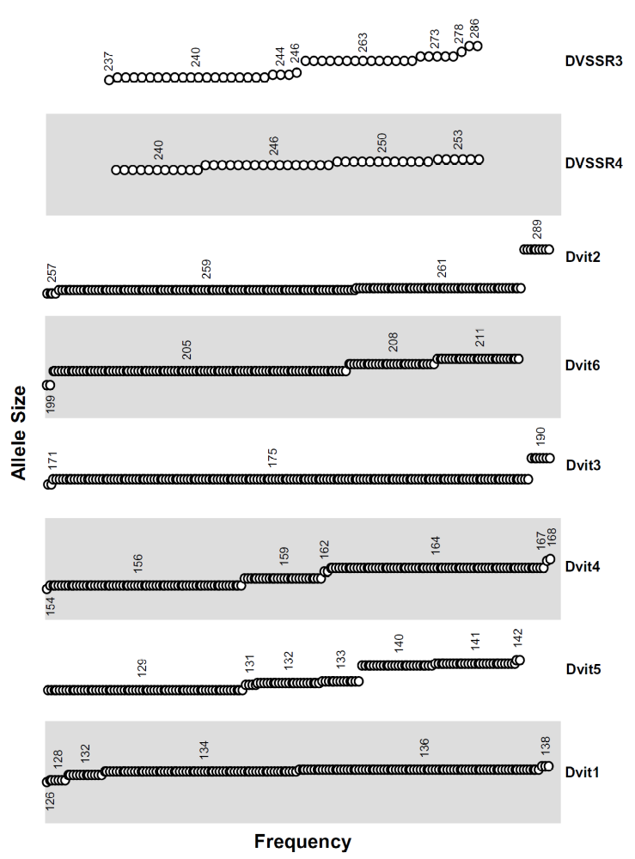
(Figure 4)
Table 1. Summary of SSR markers and genotyping methods for diagnosing genotypes of Grape Phylloxera. A) SSR marker source, repeat motif, and reported allele sizes. B) SSR markers currently in use in diagnostic laboratories; markers that are used in all three laboratories are marked in grey.
 | Region | Genotyping Method | Dvit 1 | Dvit 2 | Dvit 3 | Dvit 4 | Dvit 5 | Dvit 6 | DV  SSR 3 | DV SSR 4
A) SSR Developed |  |  | (CA)9  (CG)4 | (CT)14  (AT)16 | (AT)9  (GT)11 | (AAT)11 | (A)13 | (AAT)9 | (CA)17 | (CT)12
Corrie et al. 2002 | Australia (Victoria, NSW) | Polyacrylamide (P³³) | 128-  138 | 257-  289 | 171-190 | 154-  168
Vorwerk & Forneck 2006  Umina et al. 2007 | Europe (Germany, France, Spain) | Polyacrylamide (Silver Staining) / Capillary (ALF sequencer) | 128-  142 | 257-  289 | 171-190 | 156-  171 | 126-  142 | 199-211
Lin et al. 2006 | California & Europe | Polyacrylamide (Silver Staining) |  |  |  |  |  |  | 237-286 | 240-253
B) Diagnostic Laboratories
Hoffmann Laboratory | Australia | Polyacrylamide (P³³) / (Licor) | + | + | + | + | + | + | - | -
Forneck Laboratory | Europe | Polyacrylamide (Licor) / (Silver Staining) | + | + | + | + | + | + | - | -
Walker Laboratory | North America | Capillary (ABI) / Polyacrylamide (Silver Staining) | + | + | + | + | - | + | + | +
Table 2. Summary of application of Phylloxera SSR markers. Loci marked in grey were selected as preferred standard loci in the present study.

 | Dvit 1 | Dvit 2 | Dvit 3 | Dvit 4 | Dvit 5 | Dvit 6 | DVSSR  1 | DVSSR  2 | DVSSR  3 | DVSSR  4 | DVSSR  6 | DVSSR  7 | DVSSR  9 | DVSSR  16 | DVSSR  17
Repeat type | di-nuc | di-nuc | di-nuc | tri-nuc | poly-A | tri-nuc | di-nuc | di-nuc | di-nuc | di-nuc | tri-nuc | tri-nuc | tri-nuc | poly-A | indel
SSR Employed
Corrie et al. 2002 | + | + | + | +
Corrie et al. 2003 | + | + | + | +
Corrie et al. 2004 | + | + | + | +
Vorwerk & Forneck 2006 | + | + | + | + | + | +
Lin et al. 2006 |  |  |  |  |  |  | + | + | + | + | + | + | + | + | +
Umina et al. 2007 | + | + | + | + | + | +
Vorwerk & Forneck 2007 | + | + | + | + | + | +
Herbert et al. 2010 | + | + | + | + | + | +
Korosi et al. 2011 | + | + | + | + | + | +
Sun et al. 2011 |  |  |  | + |  |  | + | + |  | + |  |  | + | + | +
Vorwerk & Forneck 2010 | + | + | + | + | + | +
#### … ADD any others ?

Diagnostic Laboratories 2012:
Hoffmann Laboratory | + | + | + | + | + | +
Forneck Laboratory | + | + | + | + | + | +
Walker Laboratory | + | + | + | + |  | + |  |  | + | +

Table 3. a) Microsatellite allele sizes (and mitochondrial haplotype) for common strains of Grape Phylloxera from Australia. Proposed in the current study as reference samples. b) Allele size adjustments caused by addition of universal primer tails (see Supplementary Material) and genotyping on a capillary platform (see main text, and Figure 3).
 | Strain | (mtDNA) | Dvit1 | Dvit2 | Dvit3 | Dvit4 | Dvit5 | Dvit6 | DVSSR3 | DVSSR4 | Reference
a) Continent
Australia  Australia | G1  G4 | Hap C  Hap A | 128/136  128/136 | 259/289  259/289 | 175/190  175/190 | 159/159  159/168 | 131/133  133/142 | 211/211  199/211 | 235/280  235/280 | 248/253  253/255 | (Corrie et al. 2002, Umina et al. 2007, & Present Study).
b) Capillary Genotyping
Tailed primer length * |  |  | -17 | -18 | -18 | -15 | -15 | -15 | -17 | -15 | (Present Study)
Capillary adjustment ** |  |  | +0 | +4 | +2 | +3 | +3 | +3 | N/A *** | N/A *** | (Present Study)
* Adjustment required (Dvit and DVSSR losi) due to addition of universal primer tail to locus specific Forward primers (sensu Blacket et al. 2012).
** Adjustment required (Dvit loci) due to incremental size differences (sensu Moran et al. 2006) between genotyping platforms (see Figure 3).
*** No adjustment required (DVSSR loci) as original alleles were sized based on relative size compared with known size standards (Lin et al. 2006).
Supplementary Material: PCR primers and amplification conditions employed in multiplex PCR reactions.

PCR Primers:
Forward primer tails are underlined (below). Universal tail names refer to Blacket et al., 2012.

Primers for (FAM) Multiplex 1: (Dvit4:Dvit6:DVSSR4, 1:2:1 relative primer ratios)
Dvit4_F_Tail_A 5’-GCCTCCCTCGCGCCATCTTCAAAAATGTTACATGAT-3’ (Corrie et al., 2002)
Dvit6_F_Tail_A 5’-GCCTCCCTCGCGCCATGGACGATGGTTTTCATAGC-3’ (Forneck et al., 2006)
DVSSR4_F_Tail_A 5’-GCCTCCCTCGCGCCATGGTATTCACCTTGGAGCCTAG-3’ (Lin et al., 2006)
Dvit4_R 5’-TATACAATGAATGGTATCAATTC-3’ (Corrie et al., 2002)
Dvit6_R 5’-TTGATTGTCATTGGTTTTGC-3’ (Forneck et al., 2006)
DVSSR4_R 5’-GCTACTGAAACCCCTTCAACAC-3’ (Lin et al., 2006)
Tail A (FAM) (universal fluorescently labelled primer) 5’-FAM-GCCTCCCTCGCGCCA-3’ (Blacket et al., 2012)

Primers for (PET) Multiplex 2: (Dvit1:DVSSR3, 1:2 relative primer ratios)
Dvit1_F_Tail_D 5’-CGGAGAGCCGAGAGGTGCGTTCGTTCTGGTATGGTTATT-3’ (Corrie et al., 2002)
DVSSR3_F_Tail_D 5’-CGGAGAGCCGAGAGGTGAGCATGTGAGGTGCAAGGC-3’ (Lin et al., 2006)
Dvit1_R 5’-TAACGACCCGACTGAAATGTAG-3’ (Corrie et al., 2002)
DVSSR3_R 5’-CCTCGGGCGGAACAATCG-3’ (Lin et al., 2006)
Tail D (PET) (universal fluorescently labelled primer) 5’-PET-CGGAGAGCCGAGAGGTG-3’ (Blacket et al., 2012)

Primers for (VIC) Multiplex 3: (Single locus)
Dvit5_F_Tail_B 5’-GCCTTGCCAGCCCGCGAAATCCGTTCGGTGAGAGC-3’ (Umina et al., 2007)
Dvit5_R 5’-TATGGTCAATGGTCAATCCGTC-3’ (Umina et al., 2007)
Tail B (VIC) (universal fluorescently labelled primers) 5’-VIC-GCCTTGCCAGCCCGCG-3’ (Blacket et al., 2012)

Primers for (NED) Multiplex 4: (Dvit2:Dvit3, 2:1 relative primer ratios)
Dvit2_F_Tail_C 5’-CAGGACCAGGCTACCGTGGCTTAATTTTGTGTCTCAAGTTA-3’ (Corrie et al., 2002)
Dvit3_F_Tail_C 5’-CAGGACCAGGCTACCGTGCCAAAACAACCAAGATTTTCTCC-3’ (Corrie et al., 2002)
Dvit2_R 5’-TAATGCTTCGTTTTCTAAGTGC-3’ (Corrie et al., 2002)
Dvit3_R 5’-GATCCAAACTATGACAAACACCC-3’ (Corrie et al., 2002)
Tail C (NED) (universal fluorescently labelled primer) 5’-NED-CAGGACCAGGCTACCGTG-3’ (Blacket et al., 2012)

Master Mix:
Each 10µl PCR reaction consisted of:
5µl of 2 x Qiagen Multiplex PCR Master Mix; 1µl of 10 x mix of Reverse primers (containing 2-4µM of each R primer*); 0.5µl of 10 x mix of tailed Forward primers (containing 2-4µM of each F primer*); 1µl of the appropriate fluorescently labelled universal primer (4µM stock) corresponding to tailed forward primer; 0.5 µl of RNAse free water; 2µl of template DNA.
(Note: Initial PCR trials involving the addition of Q-Solution resulted in the loss of some loci from multiplex reactions, Q-Solution was therefore not used).

 | Master Mix 1  (FAM)  (x 1 reaction) | Master Mix 2  (PET)  (x 1 reaction) | Master Mix 3  (VIC)  (x 1 reaction) | Master Mix 4  (NED)  (x 1 reaction)
2 x Qiagen Multimix | 5 µl | 5 µl | 5 µl | 5 µl
R 10 x Primer Mix (2-4µM)* | 1 µl | 1 µl | 1 µl | 1 µl
F 10 x Primer Mix (2-4 µM)* | 0.5 µl | 0.5 µl | 0.5 µl | 0.5 µl
Tail A (FAM) (4µM) | 1 µl | - | - | -
Tail B (VIC) (4µM) | - | - | 1 µl | -
Tail C (NED) (4µM) | - | - | - | 1 µl
Tail D (PET) (4µM) | - | 1 µl | - | -
dH₂O | 0.5 µl | 0.5 µl | 0.5 µl | 0.5 µl
Template DNA | 2 µl | 2 µl | 2 µl | 2 µl
TOTAL: | 10 µl | 10 µl | 10 µl | 10 µl

(* Locus primers for each Master Mix mixed at ratios listed above)

PCR Amplification:
Initial enzyme activation at 95ºC for 15 minutes; 35 cycles of PCR amplification denaturing at 94ºC for 30 seconds; annealing at 45 ºC (Multiplex 1), 47ºC (Multiplex 2), 49ºC (Multiplex 3), or 57ºC (Multiplex 4) for 90 seconds; extending at 72ºC for 60 seconds; with a final extension at 60ºC for 30 minutes (to ensure all fragments generate an “A-overhang”).

